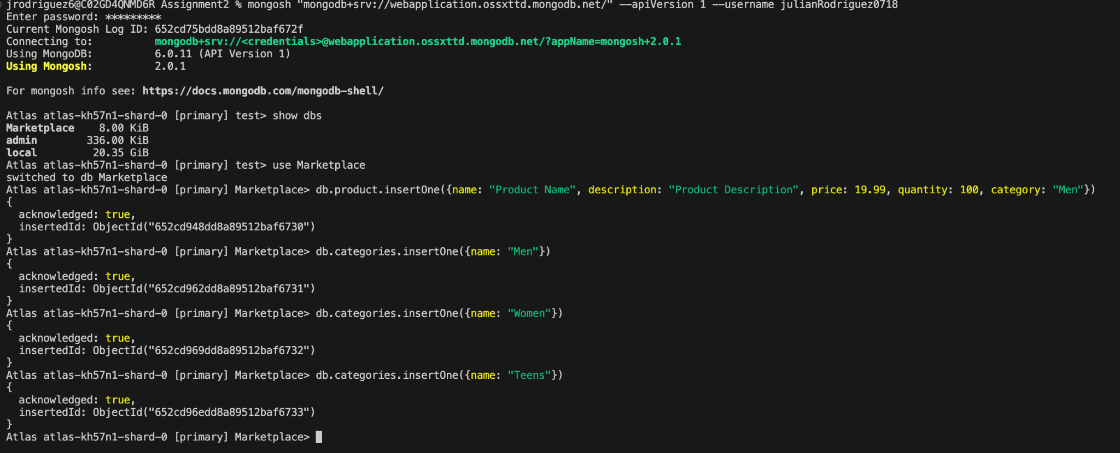

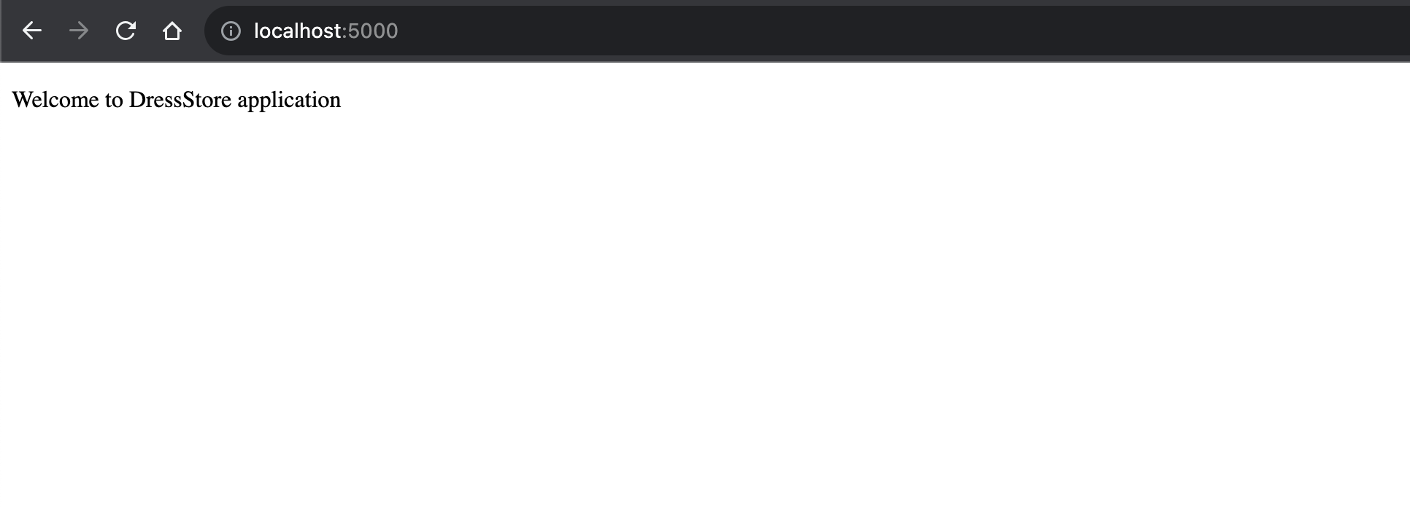

POST

/api/products

{

"name": "PC",

"description": "DELL",

"price": "1000",

"quantity": "2",

"category": "Man"

}

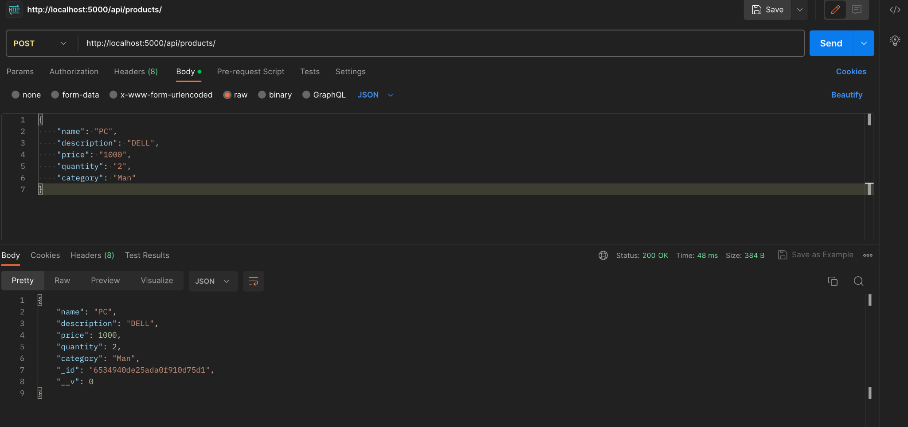

{

"name": "Iphone",

"description": "Iphone 15 pro",

"price": "2000",

"quantity": "1",

"category": "Teen"

}

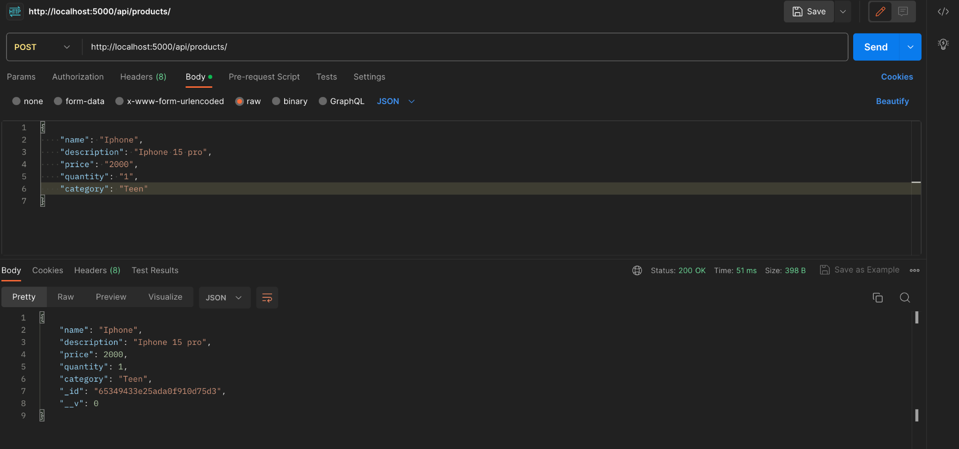

Atlas MongoDB database:

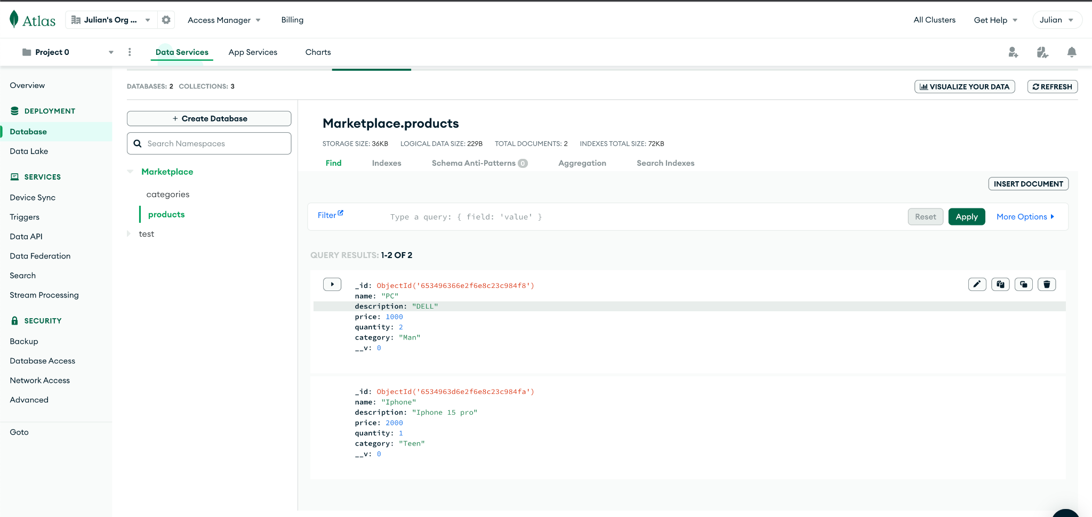

GET

/api/products

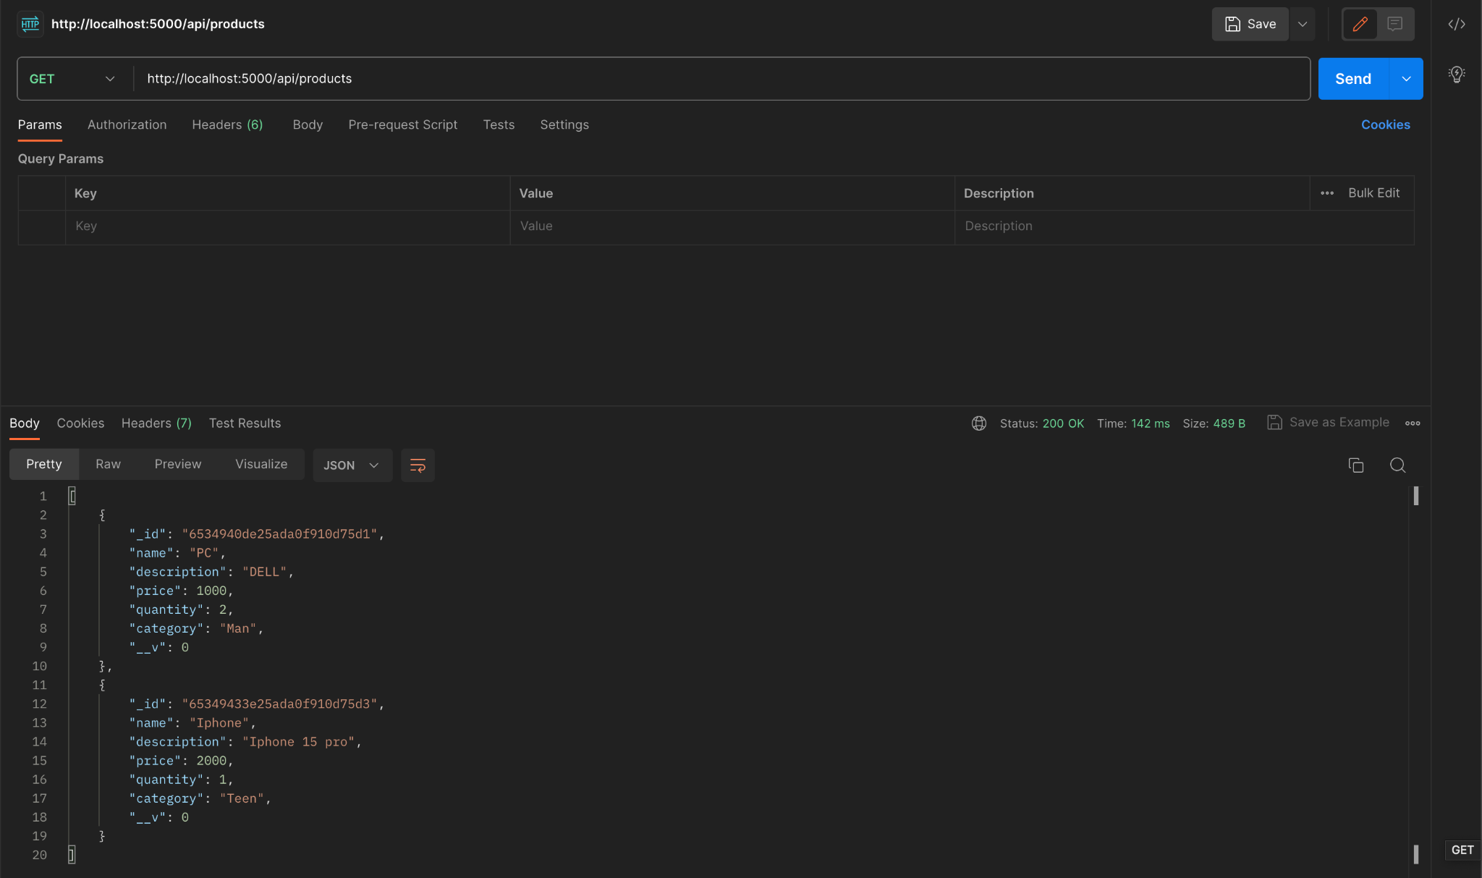

GET

/api/products/65349433e25ada0f910d75d3

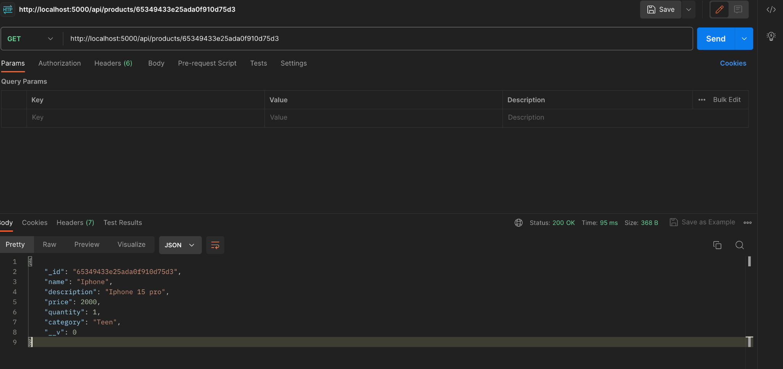

GET

/api/products?name=PC

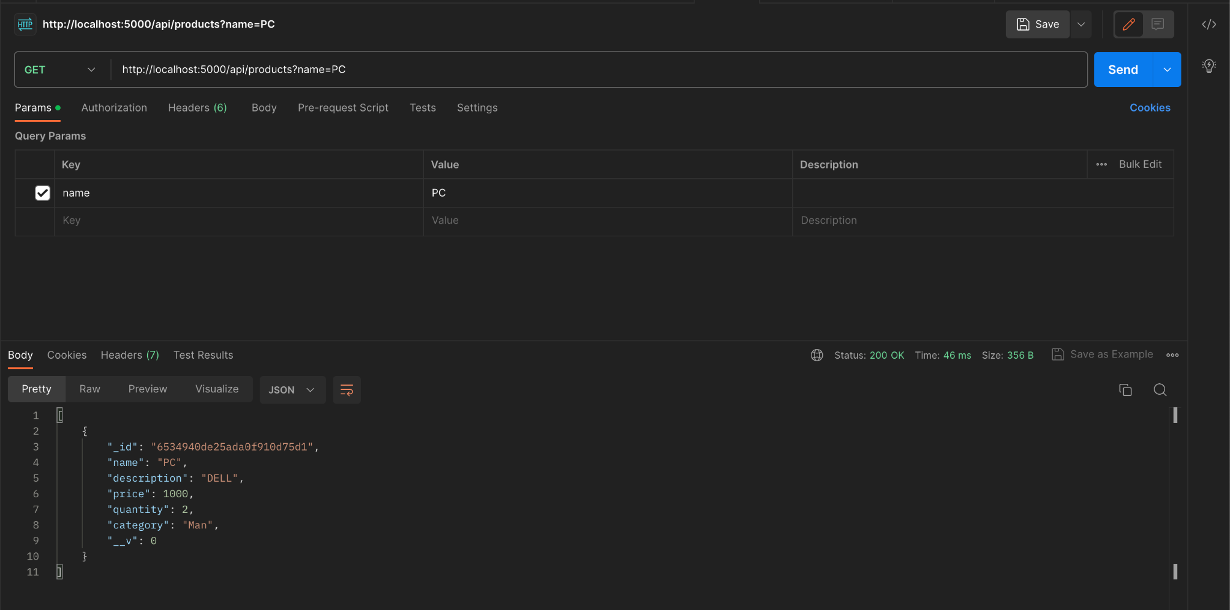

PUT

/api/products/:id

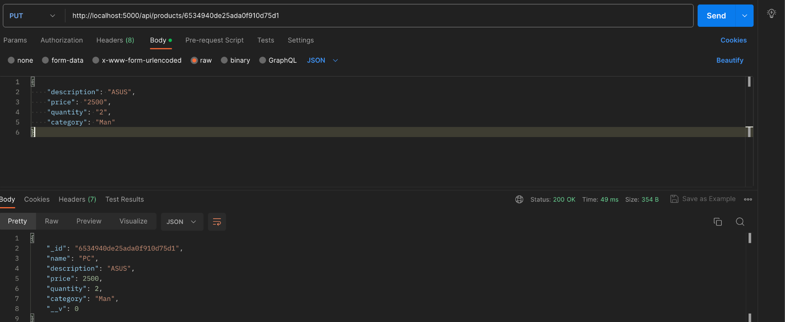

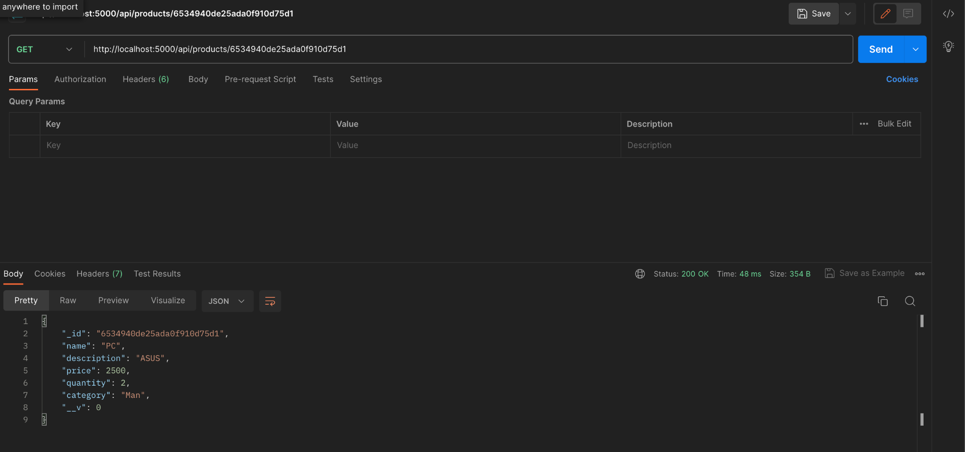

DELETE

/api/products

